Model : ComplementNB

Feature set: word2vec

Without any over/undersampling :

Performance on test:

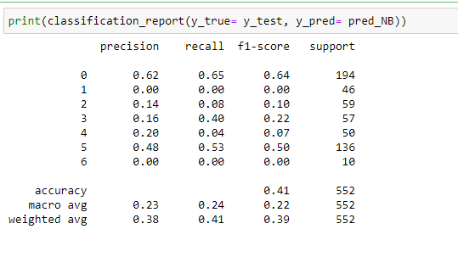

Oversampling: sampling_strategy= ‘minority’

Performance on test:

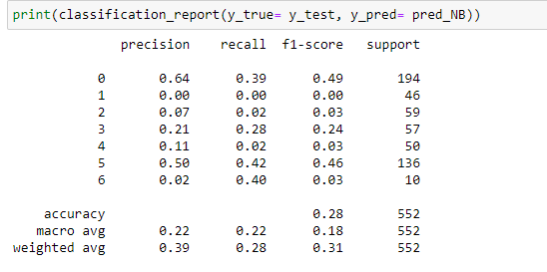

Oversampling: sampling_strategy= ‘auto’ / ‘not majority’

Performance on test:

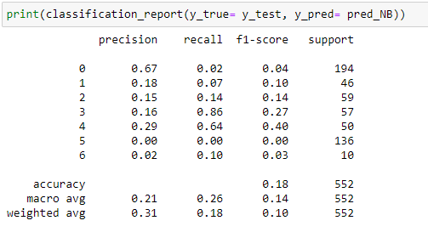

UnderSampling: sampling_strategy= ‘auto’ / ‘not majority’

Performance on test:

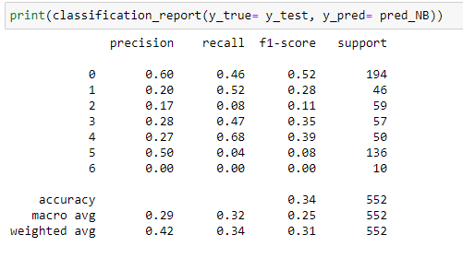

UnderSampling: sampling_strategy= ‘majority’

Performance on test:

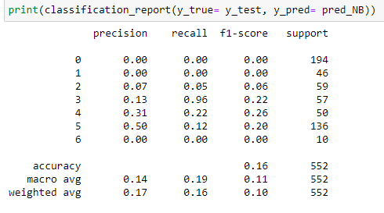

**TFIDF**

No under/over sampling

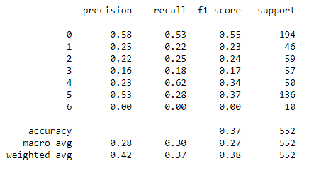

Undersampling = majority

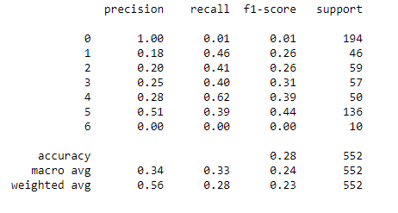

Undersampling: auto

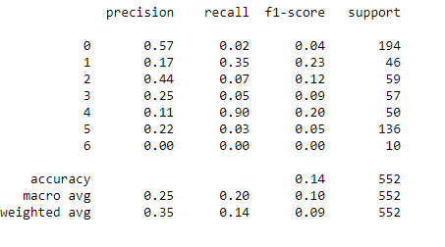

Oversampling: auto

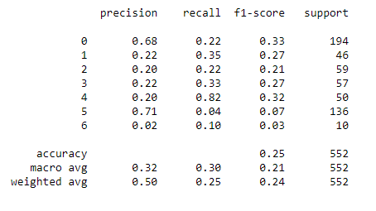

Oversampling: minority

